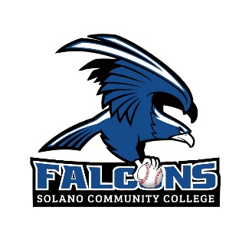
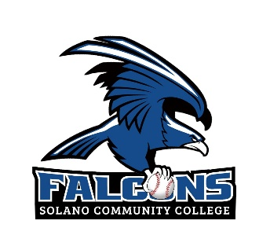
N O N – C O N F E R E N C E G A M E S
DAY | DATE | TIME | OPPONENT |  | LOCATION
Tue | Jan 16 | 12 pm | CC of San Francisco | Solano
Sat | Jan 20 | 11 am | Feather River | Solano
Fri | Jan 26 | 1 pm | Butte College | Solano
Sat | Jan27 | 1 pm | Butte College | Oroville
Mon | Jan 29 | 2 pm | Butte College | Solano
Fri | Feb 2 | 11 am | Lassen College | Solano
Sat | Feb 3 | 12 pm | Lassen College | Solano
Tue | Feb 6 | 2 pm | American River | Sacramento
Thu | Feb 8 | 2 pm | Diablo Valley College | Pleasant Hill
Fri | Feb 9 | 12 pm | Diablo Valley College | Solano
Tue | Feb 13 | 2 pm | Skyline College | Solano
Thu | Feb 15 | 2 pm | Da Anza College | Cupertino
Sat | Feb 17 | 1 pm | Cabrillo College | Solano
Tue | Feb 20 | 2 pm | Cabrillo College | Aptos
Thu | Feb 22 | 2 pm | Skyline College | San Bruno
Fri | Feb 23 | 2 pm | Monterey Peninsula | Solano
Sat | Feb 24 | 1 pm | Monterey Peninsula | Monterey
Thu | Feb 29 | 2 pm | Yuba College | Marysville
Thu | Mar 7 | 2 pm | Contra Costa College | San Pablo
Sat | Mar 9 | 2 pm | Laney College | Oakland
B A Y V A L L E Y C O N F E R E N C E G A M E S
Tue | Mar 12 | 2:30 pm | Los Medanos College | Antioch
Thu | Mar 14 | 2:30 pm | Los Medanos College | Solano
Sat | Mar 16 | 1 pm | Los Medanos College | Antioch
Tue | Mar 19 | 2:30 pm | Contra Costa College | Solano
Thu | Mar 21 | 2:30 pm | Contra Costa College | San Pablo
Sat | Mar 23 | 2:30 pm | Contra Costa College | Solano
Tue | Mar 26 | 2:30 pm | Mendocino College | Ukiah
Thu | Mar 28 | 2:30 pm | Mendocino College | Solano
Fri | Mar 29 | 2:30 pm | Mendocino College | Ukiah
Tue | Apr 2 | 2:30 pm | Yuba College | Solano
Wed | Apr 3 | 2:30 pm | Yuba College | Marysville
Fri | Apr 5 | 2:30 pm | Yuba College | Solano
Tue | Apr 9 | 2:30 pm | Laney College | Solano
Thu | Ap 11 | 2:30 pm | Laney College | Oakland
Fri | Apr 12 | 2:30 pm | Laney College | Solano
Tue | Apr 16 | 2:30 pm | College of Marin | Kentfield
Thu | Apr 18 | 2:30 pm | College of Marin | Solano
Fri | Apr 19 | 2:30 pm | College of Marin | Kentfield
Tue | Apr 23 | 2:30pm | Napa Valley College | Solano
Thu | Apr 25 | 2:30pm | Napa Valley College | Napa
Fri | Apr 26 | 2:30 pm | Napa Valley College | Solano
P O S T S E A S O N G A M E S
May 5 – 6 | Regional Playoffs | TBA | TBA
Head Coach: Scott Stover, scott.stover@solano.edu, 707-864-7822
Assistant Coaches: Kyle Stafford, Brian Guinn, Brian Houle, Michelle Hobbs, Jon Harris
Athletic Director: Erik Visser, erik.visser@solano.edu, 707-865-7126
Sports Medicine Director: Kristin Olson, kristin.olson@solano.edu,707-864-7239

