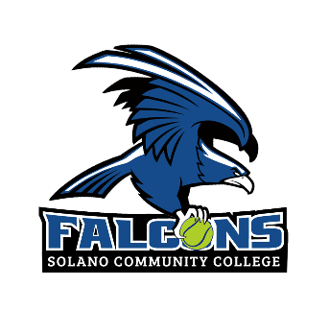
N O N – C O N F E R E N C E M A T C H E S
DAY | DATE | TIME | OPPONENT | LOCATION
Fri | Jan 26 | 8 am | West Valley Doubles Tournament | Saratoga
Fri | Feb 9 | 8 am | TBD | Modesto
Sat | Feb 10 | 8 am | TBD | Modesto
Tue | Feb 13 | 1 pm | Chabot | Hayward
Fri | Feb 16 | 2 pm | Cabrillo | Solano
B I G 8 N O R T H M A T C H ES
Tue | Feb 20 | 1 pm | Diablo Valley College | Solano
Fri | Feb 23 | 1 pm | Shasta College | Redding
Fri | Mar 1 | 1 pm | Folsom Lake College | Solano
Tue | Mar 5 | 1 pm | Modesto College | Modesto
Fri | Mar 8 | 1 pm | American River College | Sacramento
B I G 8 N O R T H P L A Y O F F M A T C H E S
Tue, Mar 12 | TBD | 1 pm | TBA
Fri., Mar 15 | Quarter Finals | 1 pm | TBA
Tue., Mar 19 | Semi Finals | 1 pm | TBA
Fri., Mar 22 | Finals | 1 pm | TBA
B I G 8 N O R T H T O U R N A M E N T
April 4-6 | TBD | 1 pm | TBD
S T A T E C H A M P I ON S H I P S
April 24-28 | TBD | TBD | Ojai, CA

Head Coach: Sierra Shackelford, sierra.shackelford@solano.edu, 707-864-4719
Assistant Coach: Rafael Rovira, rafael.rovira@solano.edu, 707-864-4719
Athletic Director: Erik Visser, erik.visser@solano.edu, 707-864-7126
Assistant Athletic Director: Alison Aubert, alison.aubert@solano.edu, 707-864-7166
Sports Medicine Director: Kristin Olson, kristin.olson@solano.edu, 707-864-7239

