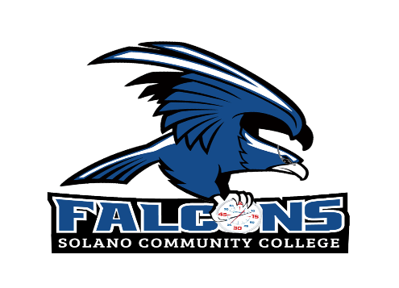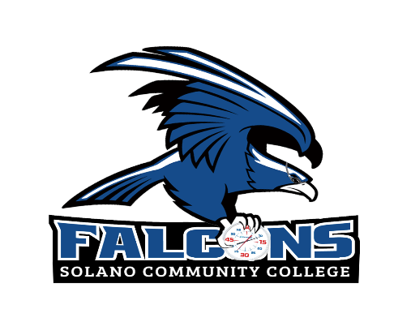

2024 Swimming and Diving Schedule

Date Day Opponent Location Time
February 10 Saturday CCSF Invitational San Francisco 10AM
February 23 Friday Coast Conference Kick Off College of Marin 10AM
March 8 Friday Marin Invitational College of Marin 10AM
March 29 Friday Hawk Invitational Los Positas 10AM
March 30 Saturday Hawk Invitational Los Positas 10AM
April 6 Saturday Chabot Invitational Hayward 10AM
April 13 Saturday Nor Cal Diving TBD 10AM
April 18-20 Thu/Fri/Sat Coast Conference Championships College of Marin 10AM
May 2-4 Thu/Fri/Sat State Championships Orange Coast All Day

