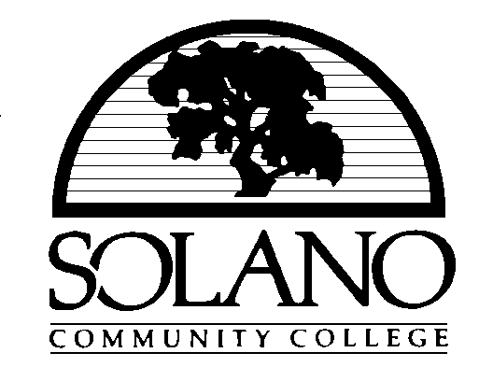

REVISED AGENDA

SOLANO COMMUNITY COLLEGE DISTRICT

GOVERNING BOARD

Notice of Special Meeting

Wednesday, August 30, 2006

7:00 p.m.

Solano Community College

Administration Building, Room 626
4000 Suisun Valley Road
Fairfield, CA 94534-3197

1. CALL TO ORDER

2. PLEDGE OF ALLEGIANCE TO THE FLAG OF THE UNITED STATES OF AMERICA

3. ROLL CALL

Jerry R. Wilkerson, President
Pam Keith, Vice President
James M. Claffey
Denis Honeychurch, J.D.
Phil McCaffrey
Vacancy from Area #3 – Vallejo
A. C. “Tony” Ubalde, Jr., Rel.D.
Lillian Nelson, Student Trustee
Paulette J. Perfumo, Ph.D., Secretary

4. APPROVAL OF AGENDA

5. COMMENTS FROM MEMBERS OF THE PUBLIC

6. INFORMATION ITEMS – NO ACTION REQUIRED

(a) Public Hearing and Information Workshop on the Official District Budgets for Fiscal Year 2006-07

(b) Update on Vallejo Center

Commitment to our Communities!

7. CLOSED SESSION

(a) Public Employee Discipline/Dismissal/Release

8. RECONVENE REGULAR MEETING

9. REPORT OF ACTION TAKEN IN CLOSED SESSION

10. ADJOURNMENT

NO OTHER BUSINESS WILL BE TRANSACTED.

PJP:pc

BOARD.SPECIALMEETING.REVISED.AGENDA.083006

